12th February 2015

**YOKOHAMA to Exhibit at 2015 Geneva Motor Show**

Tokyo ‒ The Yokohama Rubber Co., Ltd., announced today that it will participate again this year in the annual Geneva International Motor Show. The 85th edition of the Geneva show will be held from 5th – 15th March, with press days on 3rd – 4th March.

YOKOHAMA’s booth will feature high-performance offerings from the company’s “ADVAN” global flagship brand, including the highly attractive street sports tyre “ADVAN NEOVA AD08R” and the “ADVAN Sport V105,” which comes factory-equipped on several high-performance premium automobiles. In addition, the booth will introduce visitors to YOKOHAMA’s environmentally friendly products, including “BluEarth-A AE-50”, which combines excellent low-rolling resistance with superior wet performance, and the “GEOLANDAR SUV,” a fuel-efficient all-season tyre designed specifically for the small SUVs seen so often on city streets. This year’s display will also feature the debut of a technologically advanced tyre engineered to provide superior on-road performance for full size SUVs and pick-up trucks.

Winter season tyres also will be prominently displayed, such winter tyres as “W*drive V905” suitable for use in winter conditions across the European continent, and the ”iceGUARD STUD iG55” and the “iceGUARD STUDLESS iG50,” two tyres capable of delivering superior performance under the more severe Nordic winter conditions.

In addition to being a leading global tyre manufacturer, YOKOHAMA produces high-quality alloy wheels. The YOKOHAMA display at Geneva will feature the “AVS Model F50” and the “ADVAN Racing GT Premium Version” ‒ Racing Gold Metallic, both of which were first released in 2014. The “ADVAN Racing RZII,” introduced earlier this year at the Tokyo Auto Salon, will also be on display.

Invitation to journalists: Media representatives are invited to attend the YOKOHAMA press conference on 3rd March at 3:30pm at booth No. 4231 in Hall 4. The Company will introduce its technologically advanced new tyre for full size SUVs and pick-up trucks and provide a comprehensive information packet.

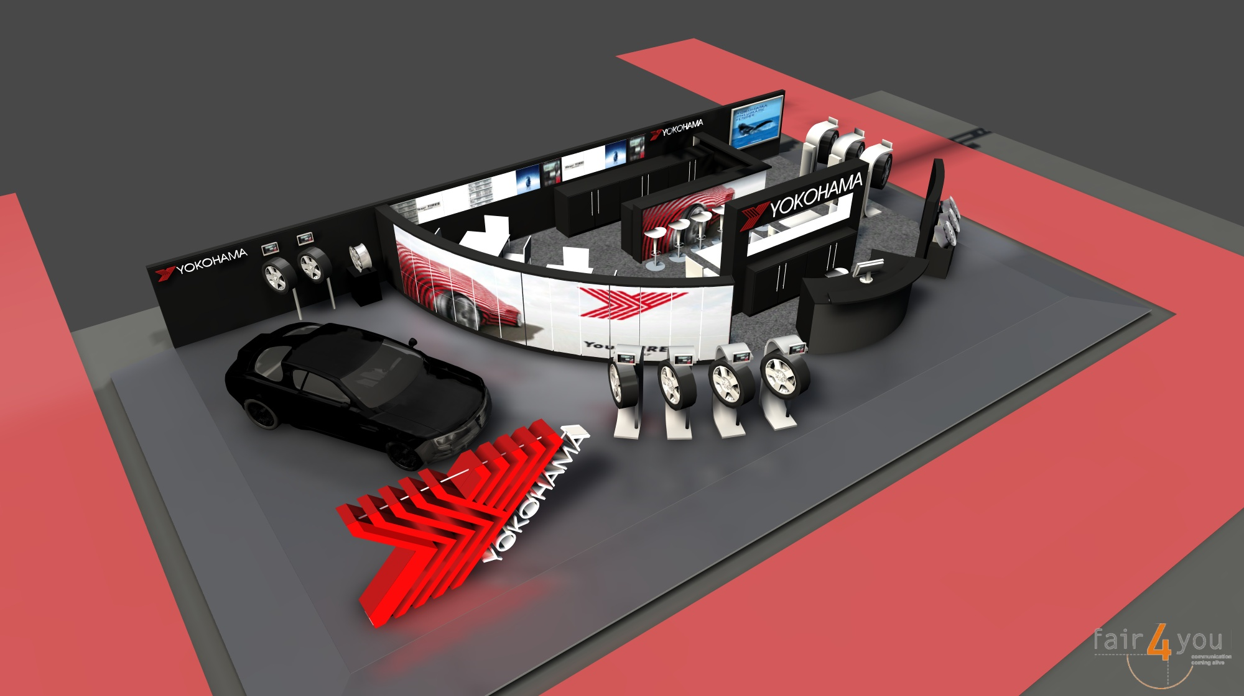

*Image of the YOKOHAMA booth*